
Mohamed Hossameldin Mahmoud Ibrahim - 800241908
Image Analysis and Computer Vision
Spring 2026
Project Report

Introduction
This code defines a systematic image processing pipeline designed to detect, isolate, and rectify a sudoku grid from a set of input images with noise applied to them which challenges the image processing approaches. The project’s functional description was achieved through the following:
- Robust image enhancement, adaptive binarization, morphological structural attenuation, contour-based outer frame isolation, convex polygon approximation, and perspective rectification into a scale-neutral square canvas.
- Dynamic synthetic font template-bank generation using OPENCV standard fonts, scale-invariant structural pixel matching for Optical Character Recognition (OCR), constraint validation, and an optimized puzzle solver.

Code Functions Description
This assignment helped familiarize the course’s main theoretical concepts with practical image processing across different problems(noise types) related to images. This assignment was also useful for using OpenCV filtering and image processing functions that help developers transform the images faced with noise as well as using numpy and matplotlib for data visualization.

1. Initialization and Loading (__init__)
The constructor serves as the entry point for the processing pipeline.
- Grayscale Conversion: It loads images using cv2.IMREAD_GRAYSCALE. Converting to grayscale.
- Data Management: It stores the raw images in a list and performs a basic sanity check to ensure the file paths provided are valid so that the code does not break.

2. Visualization (show_images_grid)
This utility function handles the display of the image set using Matplotlib.
- Grid Layout: It organizes the images into a 4x4 grid for quick visual inspection.
- Pipeline Trigger: Interestingly, the code uses a final block to automatically trigger the next stage (pre_process_images), ensuring the pipeline continues even if the display encounters a non-fatal error.
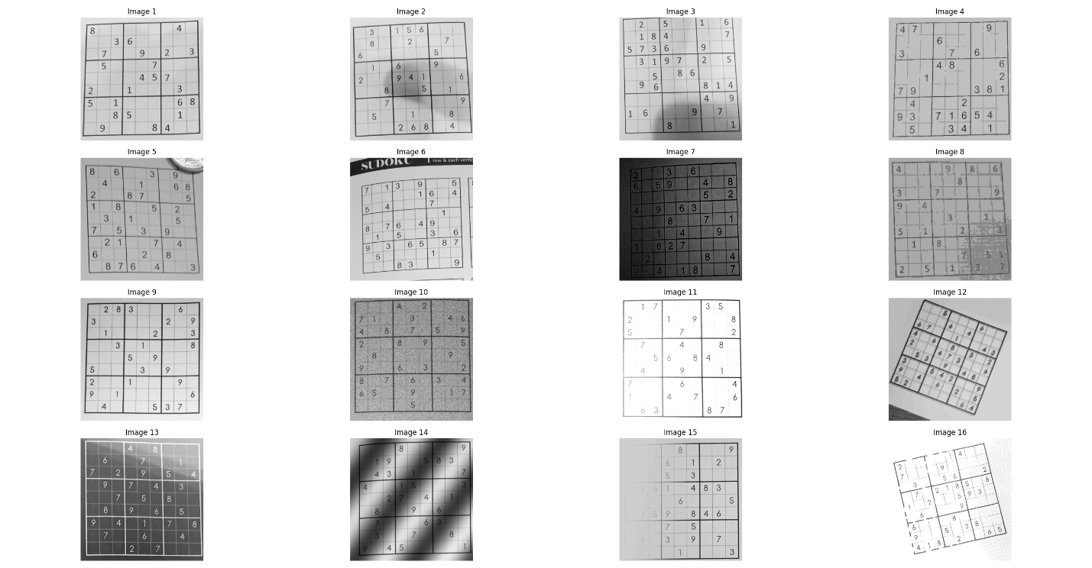
Figure 1 Input Images Plot.

3. Image Enhancement (pre_process_images)
This function applies a series of filters to prepare the images for contour detection by highlighting edges and reducing background noise.
- Contrast Limited Adaptive Histogram Equalization (CLAHE): Standard global equalization often amplifies background noise in localized dark or bright regions. This pipeline applies CLAHE with a strict clipLimit=3.0 and a localized grid tile size of 8x8. This balances localized illumination gradients, ensuring that grid lines and digits maintain high contrast against the paper substrate regardless of shadows.
- Gaussian Noise Attenuation: High-frequency variations and camera sensor grains are filtered using a 5x5 Gaussian kernel blur. This smooths out micro-textures on the paper without destroying critical structural edges.
- Adaptive Gaussian Thresholding: To separate foreground elements (lines and digits) from the background, an adaptive thresholding algorithm calculates a localized threshold for each pixel based on a Gaussian-weighted sum of its 45x45neighborhood. This successfully binarizes the image, yielding a clean, inverted (THRESH_BINARY_INV) mask.
- Morphological Dilation: A structural 3x3 square unit kernel is applied over 1 iteration of dilation. This repairs minute breaks or fragmentations along the primary grid lines caused by thresholding, resulting in continuous contours.
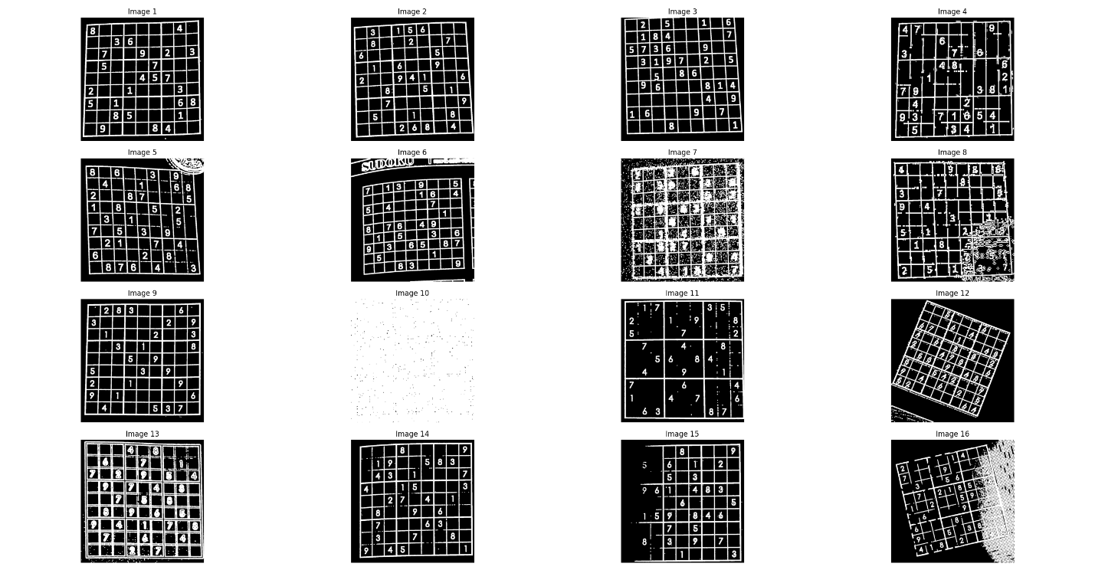
Figure 2 Resulting Images from inversing and applying morphological operations.

4. Feature Extraction (isolate_outer_frame)
This function identifies the primary object of interest within the pre-processed image.
- Contour Detection: It uses cv2.findContours to locate all shapes.
- Polygon Approximation: For each contour, it applies cv2.approxPolyDP and cv2.arcLength. This algorithm simplifies a contour shape into a polygon with fewer vertices.
- Quadrilateral Filtering: The function specifically searches for a contour with exactly 4 corners.
- Visual Feedback: The detected green frames and red corner points are shown on a plot of the original images for verification.

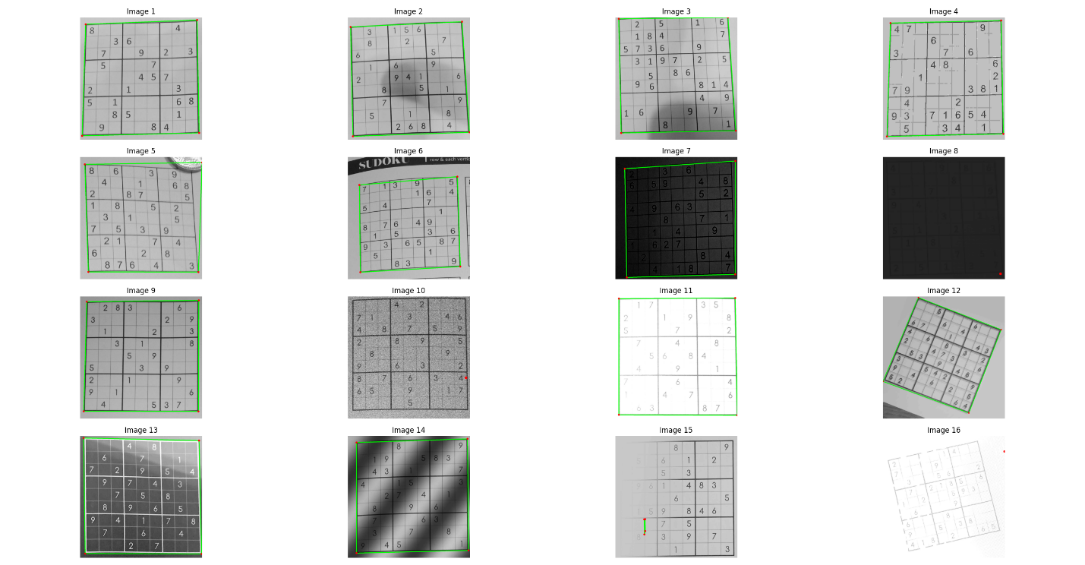
Figure 3 Resulting outer grid Identification and corner detection.

5. Geometric Transformation (straighten_grids)
This is the final stage, which performs a perspective wrap to "top-down" the detected grid.
- Corner Sorting: the code sorts the four corners into a standard order: Top-Left, Top-Right, Bottom-Right, and Bottom-Left.
- Perspective Transform: * It calculates a transformation matrix using cv2.getPerspectiveTransform.
  - It maps the distorted coordinates to a perfect square of 450x450 pixels.
- Warping: cv2.warpPerspective is applied to the original image to remove any tilt or perspective distortion from the original input image.
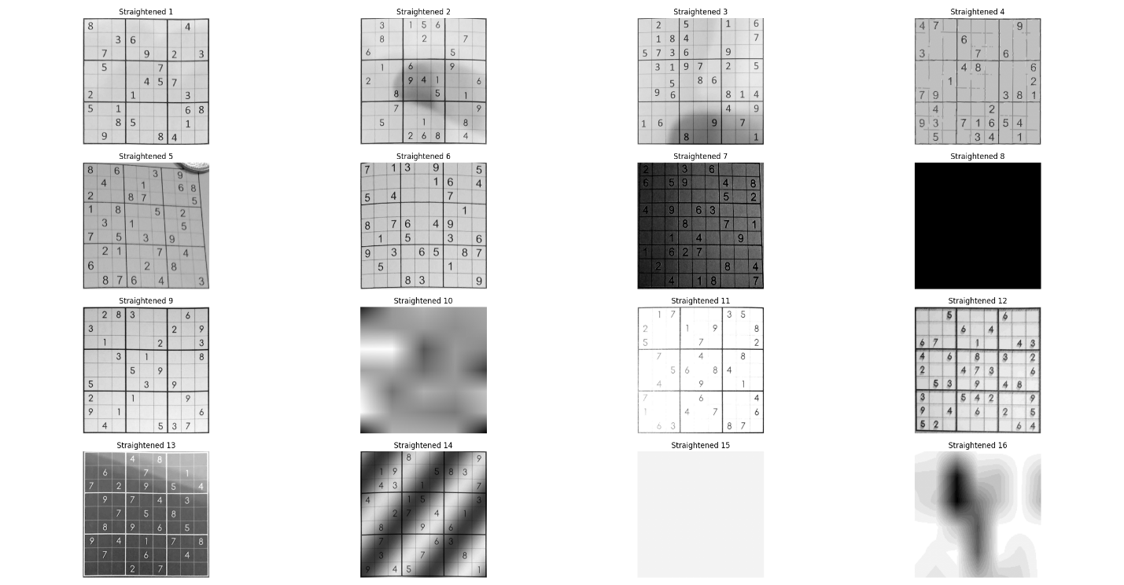
Figure 4 Output straightened images.

6. Optical Character Recognition (OCR) Implementation
As per the project specifications, machine learning models were strictly prohibited for digit recognition. Therefore, a manual pattern-matching approach was engineered to parse the numerical values from the straightened grids.
- Template Bank Generation (_build_template_bank & _normalize_digit): The code dynamically generates a dictionary of digit templates (1-9) using various OpenCV fonts (FONT_HERSHEY_SIMPLEX, DUPLEX, etc.), scales, and thicknesses. The _normalize_digit helper function ensures that both the generated templates and the extracted puzzle digits are resized to a scale-neutral 28x28 pixel canvas, centered, and blurred slightly to allow for minor shape variations during matching.
- Cell Extraction (extract_and_recognize_matrix): The 450x450 straightened grid is mathematically divided into 81 equal 50x50 cells. For each cell, margins are cleared to remove grid-line noise. Contours are evaluated to find the most probable digit blob based on area, dimensions, and aspect ratio.
- Pattern Matching: Extracted digits are compared against the template bank using cv2.matchTemplate with the cv2.TM_CCOEFF_NORMED method. The algorithm assigns the digit based on the highest correlation score, provided it passes a strict confidence threshold (e.g., > 0.55 or 0.65 for historically tricky digits like 1, 4, and 7).

7. Sudoku Solving Algorithm
Once the grid is converted into a 9x9 integer matrix, a mathematical algorithm is applied to compute the missing values.
- Grid Validation (_is_valid_starting_board): Before attempting to solve, the parsed matrix is checked for fundamental Sudoku rule violations (duplicates in rows, columns, or 3x3 sub-grids). This is a critical defense mechanism against OCR errors.
- Backtracking with MRV (solve_sudoku & _find_mrv_empty_location): The core solver utilizes a recursive backtracking algorithm. To optimize performance, it employs the Minimum Remaining Values (MRV) heuristic. Instead of scanning left-to-right, the algorithm always targets the empty cell with the fewest possible legal candidates, drastically reducing the search tree and computation time.

8. Output Generation and Visualization
To support testing, documentation, and discussions, the pipeline concludes by systematically exporting the results.
- Data Export (save_output_images): The code creates a structured local directory (Project_Outputs) containing the isolated Straightened grids and the Solved visualizations.
- Final Dashboards (display_final_results): Matplotlib is utilized to render side-by-side comparisons of the straightened perspective grids alongside the computed matrix. The output highlights originally parsed digits in red and the newly computed solutions in green for clear visual differentiation.
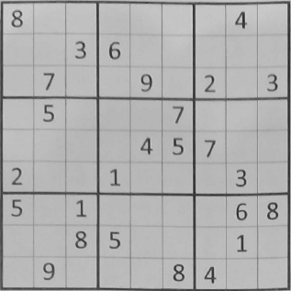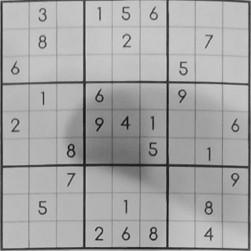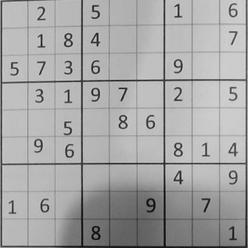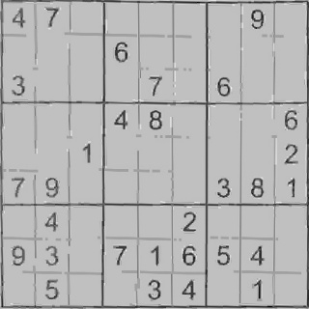
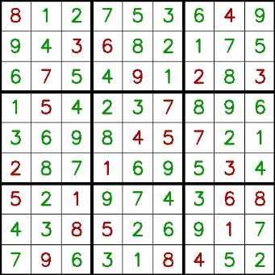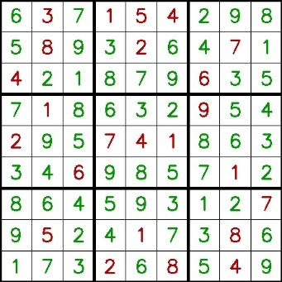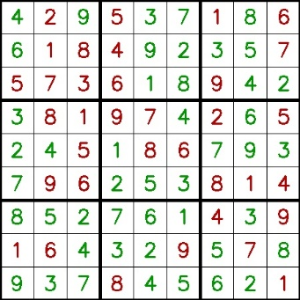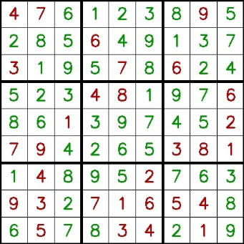

Project Outcomes and System Shortfalls

Overall Pipeline Success
The computer vision pipeline demonstrates strong resilience in the preliminary stages. The preprocessing steps (CLAHE, Gaussian Blurring, Adaptive Thresholding) and the morphological contour detection successfully mitigate severe noise, isolate the outer frames, and geometrically straighten the puzzles into perfect 450x450 matrices across varied test cases.

The OCR Bottleneck
Despite the success of the geometric transformations, the project’s primary shortfall lies in the Optical Character Recognition phase. Because the project constraints mandated the use of manual pattern matching without machine learning, the OCR system remains highly brittle.

Key limitations observed include:
- Typography Sensitivity: The cv2.matchTemplate method expects a high degree of pixel overlap. If the font of the captured Sudoku puzzle deviates significantly in serif style, italics, or weight from the OpenCV-generated templates, the correlation scores drop below the required confidence thresholds, resulting in missed digits (false negatives).
- Noise and Artifacts: Residual noise connected to a digit alters its bounding box and aspect ratio. This forces the normalization function to warp the digit incorrectly, causing severe mismatches.
- Similar Digit Confusion: Digits with similar pixel distributions (e.g., distinguishing a '1' from a '7', or a '3' from an '8' under distortion) frequently result in false positives.
- The Unsolvable State: Sudoku is a zero-tolerance game. A single misclassified digit or a missed value that violates initial board constraints renders the entire 81-cell puzzle mathematically unsolvable. Consequently, the OCR's fragility acts as a strict bottleneck, occasionally preventing the solve_sudoku function from executing successfully despite a perfectly straightened image.

Conclusion
The project successfully meets the milestones by delivering a robust geometrical processing pipeline and integrating a functional backtracking Sudoku solver. However, the outcomes clearly illustrate the limitations of classic template-matching for dynamic real-world OCR tasks. Future iterations outside of academic constraints would benefit immensely from swapping the template bank approach with a lightweight Convolutional Neural Network (CNN) or a dedicated OCR engine like Tesseract, which would bridge the gap between the currently perfect grid isolation and the mathematical solver.

References
- https://github.com/ArchitJ6/SudokuVision
- https://github.com/trflorian/sudoku-extraction
- https://github.com/cedric190703/SudokuSense
- https://docs.opencv.org/3.4/d3/dc1/tutorial_basic_linear_transform.html
- https://learnopencv.com/hough-transform-with-opencv-c-python/
- https://github.com/anhhaibkhn/ocr-opencv-python-tutorials
- https://github.com/anhhaibkhn/ocr-opencv-python-tutorials/tree/main/opencv-sudoku-solver-and-ocr

